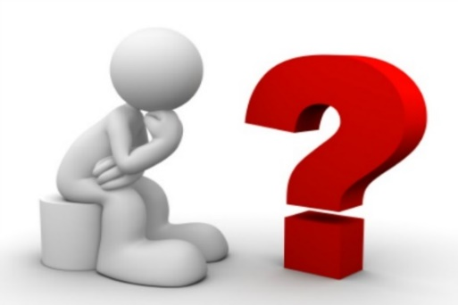
GOT QUESTIONS?

- Do you have questions about drugs? How you, your friends and your family are affected? Leave your question in this box. You don’t need to sign your name!
- Every two weeks this locked box will be checked. Answers to your questions will be posted on the following Facebook pages:
https://yatessac.weebly.com/
Penn Yan Public Library
Yates County Youth Bureau
Yates County Public Health
And on the office windows of the Council on Alcoholism & Addiction of the Finger Lakes,
112 Main Street, Penn Yan

Sponsored by the Yates County Substance Abuse Coalition
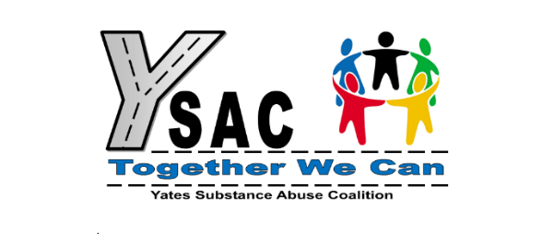

Introduction to the YSAC Question Box
The Yates Substance Abuse Coalition has provided this Message Box to you for any questions or concerns you may have regarding drugs or substances you have seen or heard about in your school or community. These situations may be affecting you or people you care about, and you want to learn more factual information from professionals who can provide the answers. The information will be shared without indicating who asked the question or concern. Your privacy will be protected!

Placed in your library for easy access, just slide your written question inside the locked box. The messages will be picked up every two weeks by a YSAC member and the answers will be posted to the websites, Facebook pages and locations below within that next week:

https://yatessac.weebly.com/
Penn Yan Public Library
Yates County Youth Bureau
Yates County Public Health
And on the office windows of the Council on Alcoholism & Addiction of the Finger Lakes,
112 Main Street, Penn Yan

Sponsored by the Yates County Substance Abuse Coalition

