Creating a Safe Environment (for Volunteers)
Online Training Instructions
All adult volunteers working with children, youth, or vulnerable adults need to complete the same training—whether they are new, renewing after 3 years, working with children/youth, or working with vulnerable adults. In-person training remains an option, and it is the only option for teen volunteers.
Introduction
There are 5 courses in the training:
1. Meet Sam
2. It Happened to Me
3. Exploitation in Elder-Serving Programs
4. Abuse Risk Management for Volunteers
5. DOR policies – Volunteers
The first four courses include action plans. These are for your enrichment. You may choose to print them or not. If you open an action plan, simply close it to return to the training.
If you have any difficulty, please call the DOR Help Desk at 1-800-844-7177 for assistance.
To Access the training:
- In the address bar of Google Chrome, type in the address www.dor.training IE will not work!
- Click on “Creating a Safe Environment” in the blue bar
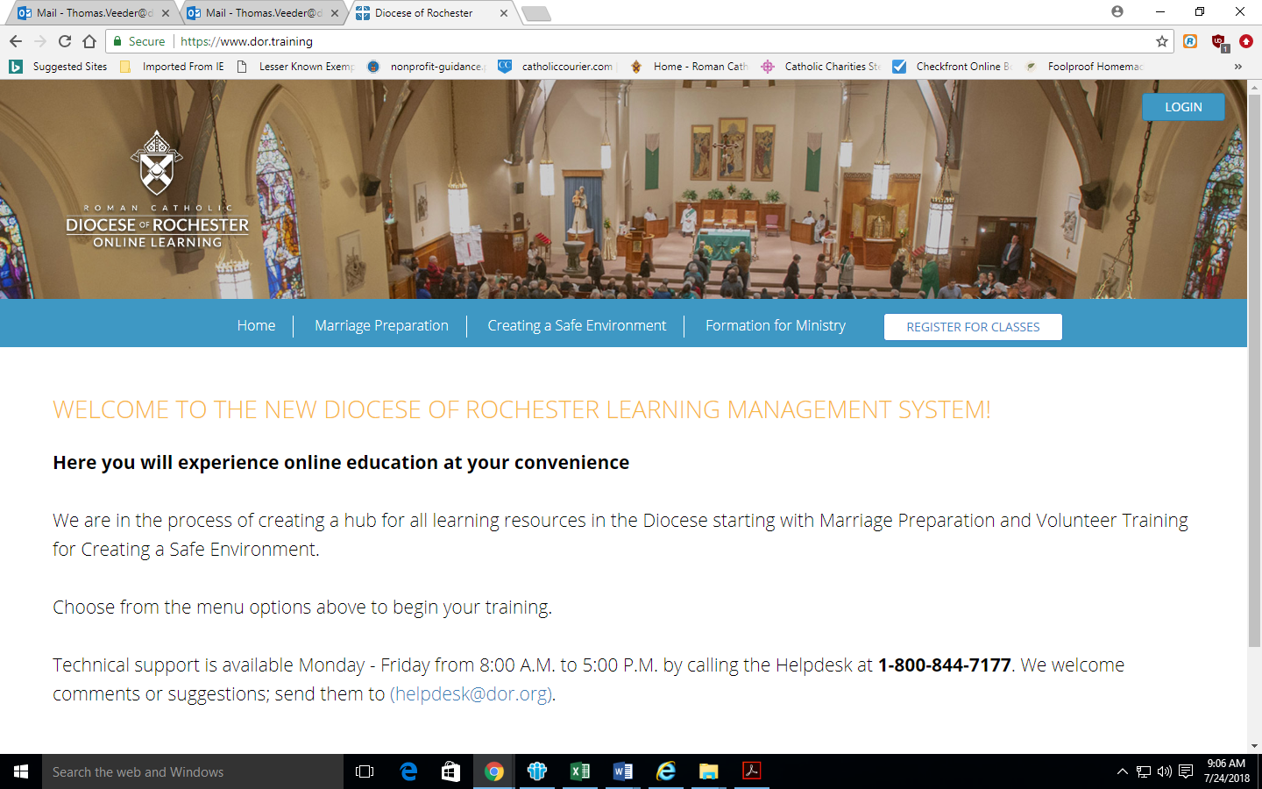
- Scroll down to select the English or Spanish version and click on “Register Now”
- Click on “Add to Cart”
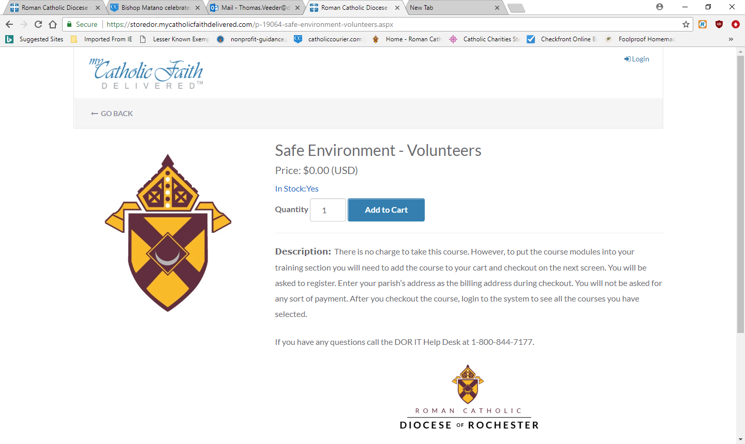
- Click on “Checkout”
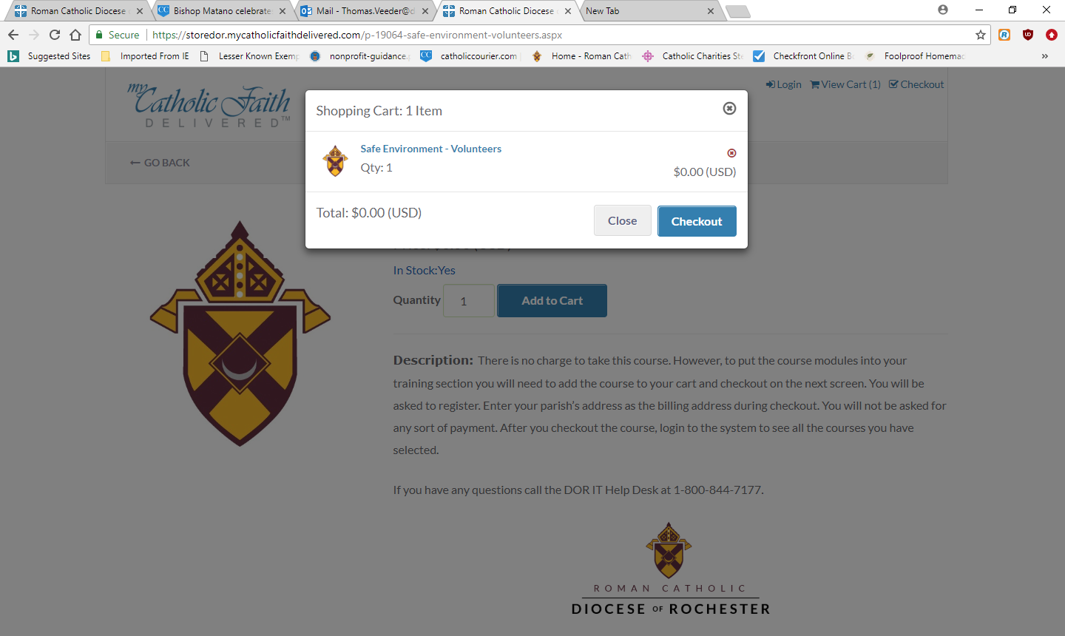
- Enter your email address and click “Save”
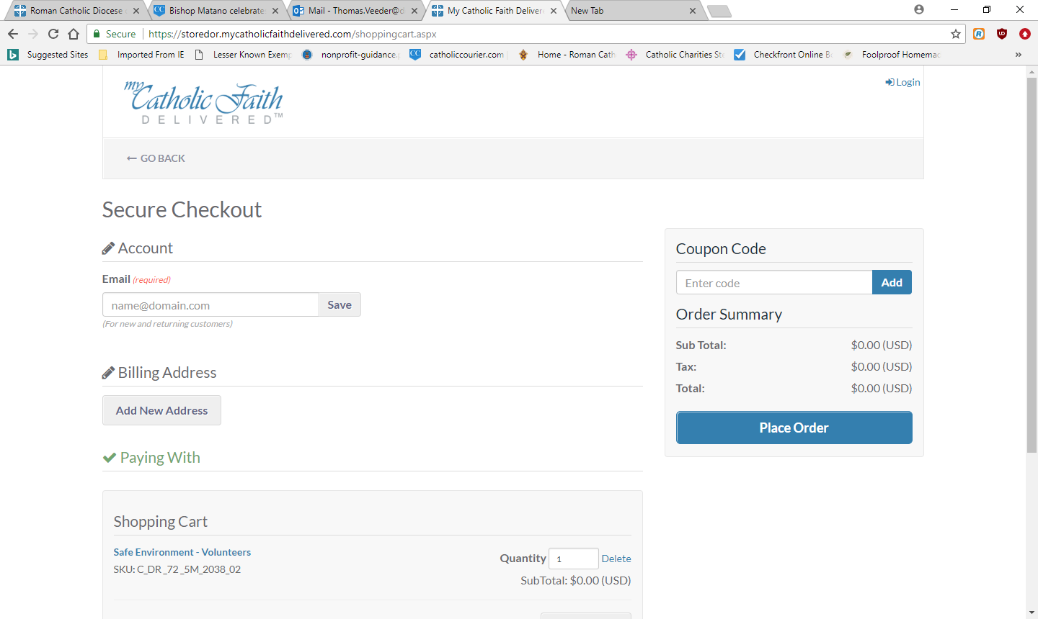
- Enter a password and click “Create Account” if this is your first time.
Your password must be between 8 and 20 characters. It must include at least 1 uppercase letter, 1 lowercase letter, 1 number, and 1 special symbol (# $ % ^ & * @ ! ~ are acceptable).
- Click on “Add New Address.”
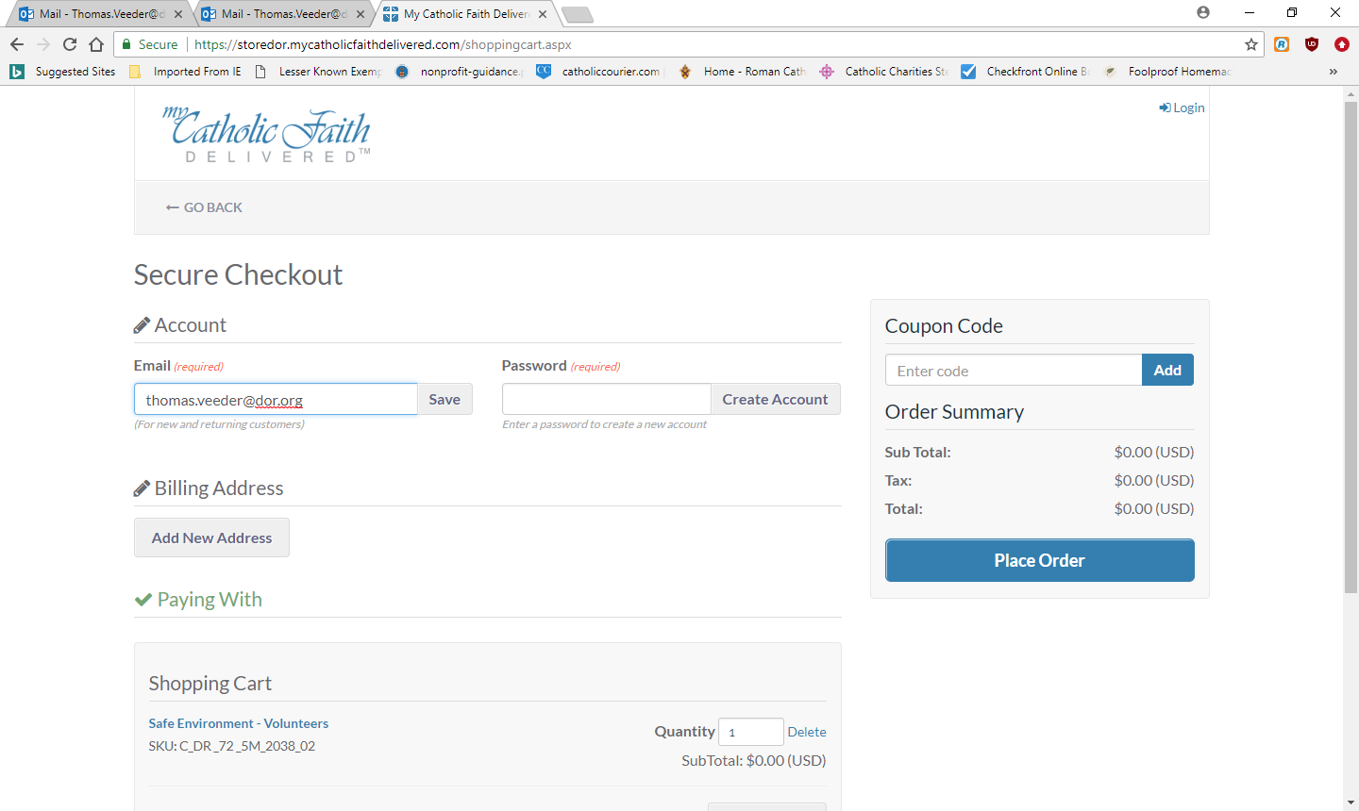

- Enter your name and the address of your Parish/School (Our Lady of the Lakes Catholic Community, 210 Keuka St., Penn Yan, NY 14527 or St. Michael’s School, 214 Keuka St., Penn Yan, NY 14527) /Ministry (Choose the title that best describes what you will do.). Remember there will be no cost for this training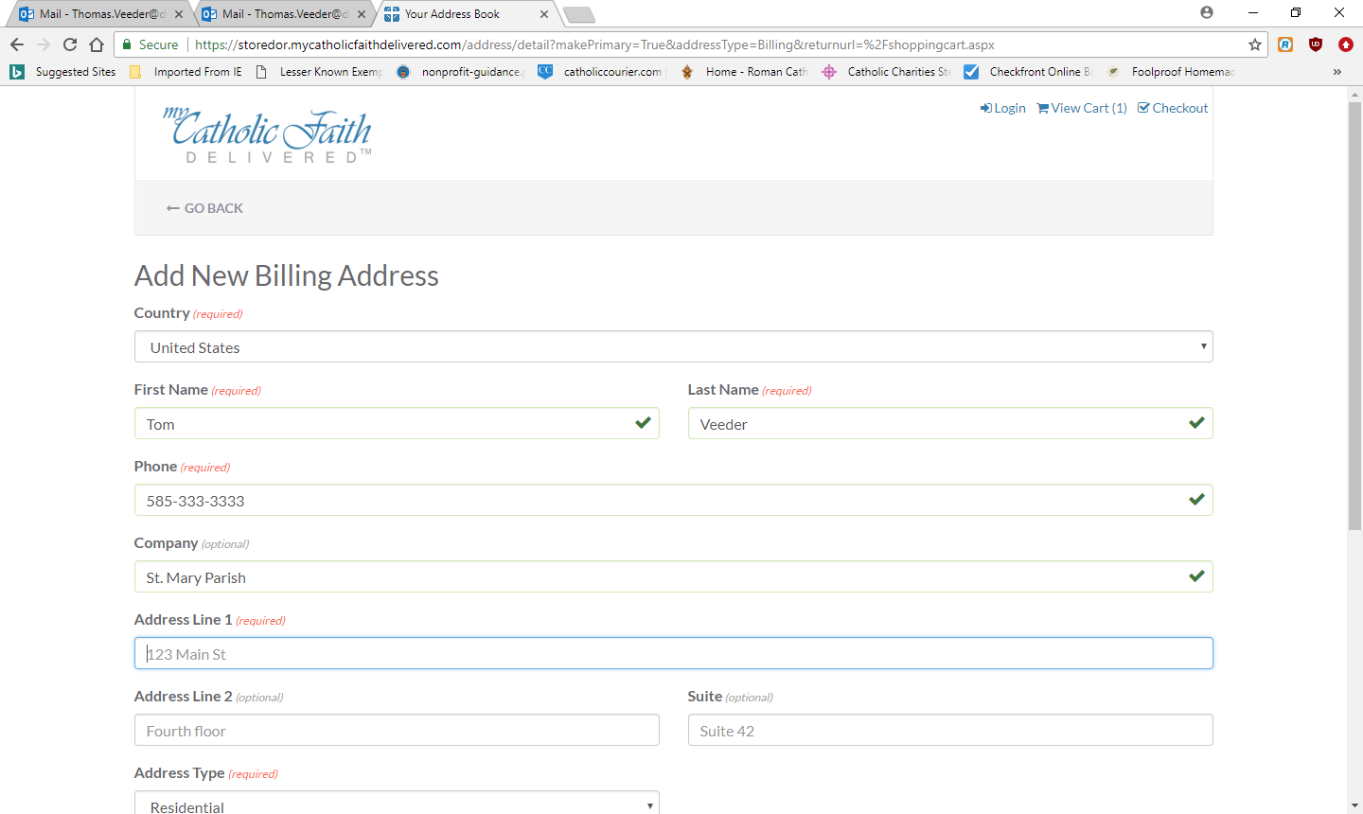
- Click on Place Order
Note: This setup in lengthy but you will only need to do it once.
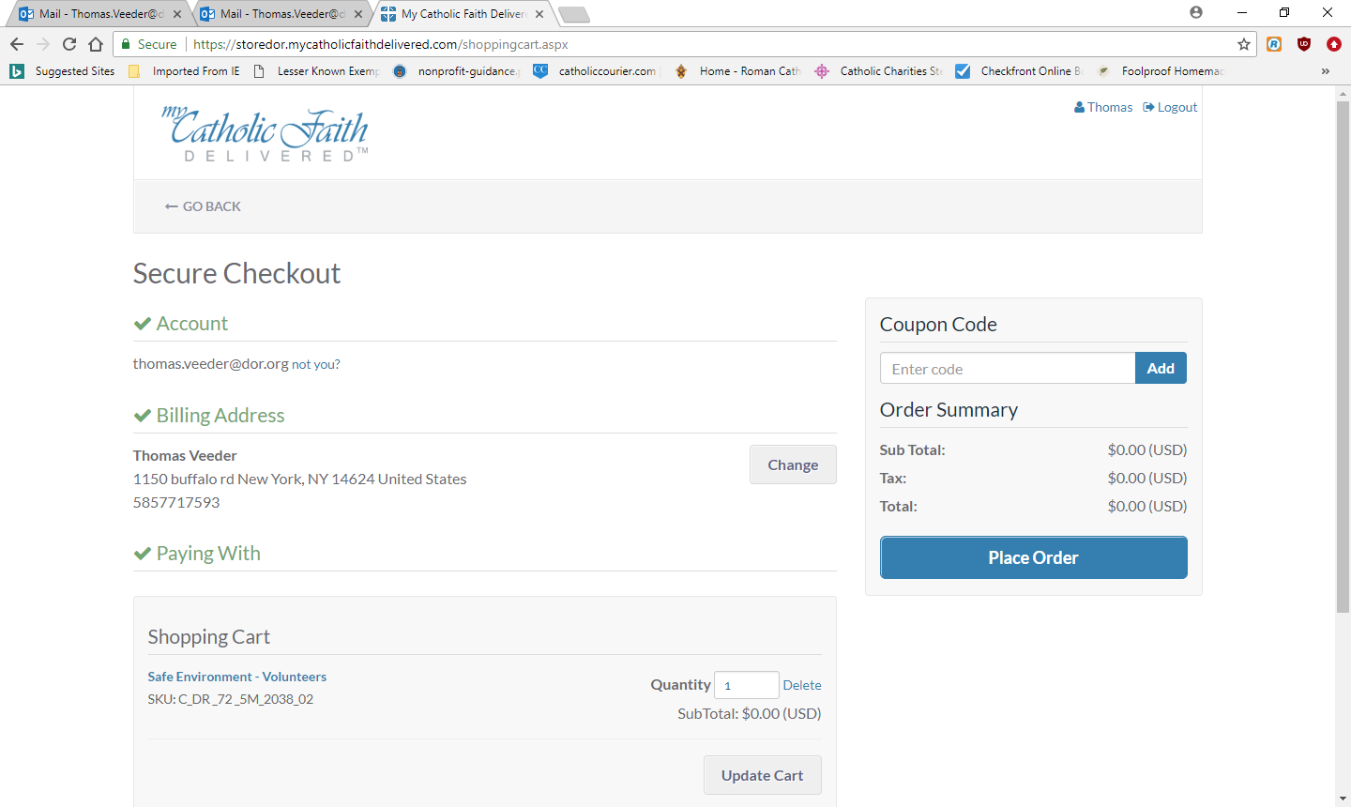
- You do not need to print the receipt since there is no cost. Some other trainings require payment. Safe Environment does not.
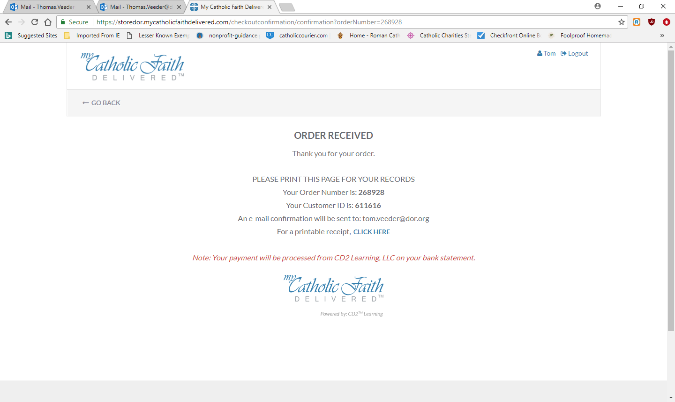
- Close everything and open a new browser. Do the following any time you want to re-enter your safe environment training. Enter www.dor.training to get to the original screen.
- Choose “Login” in the upper right hand corner to access your courses.
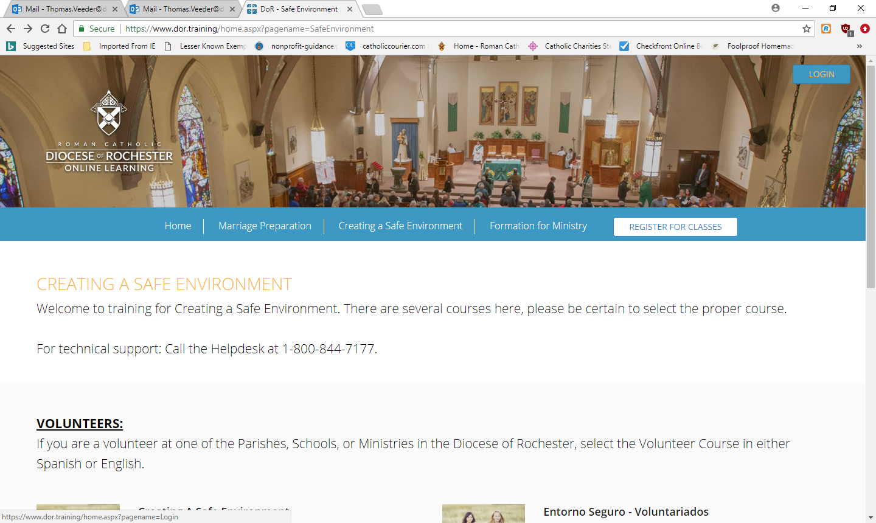
- Enter your email address and the password you just created.
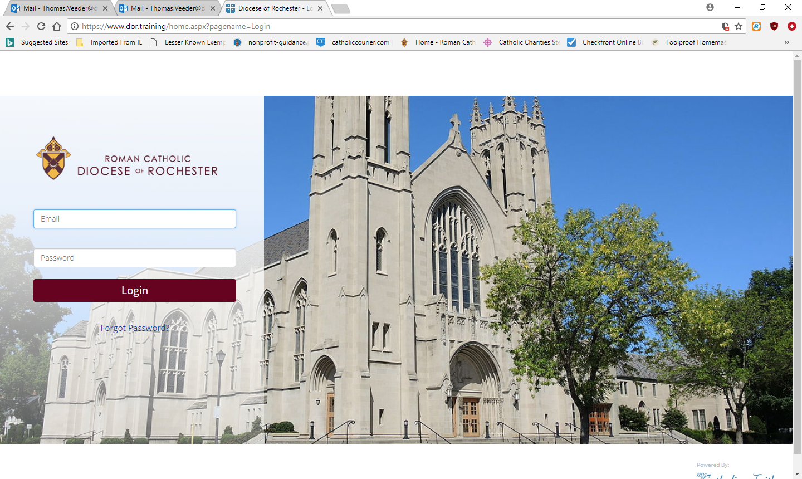15. You will be asked to select your parish/school/ministry.
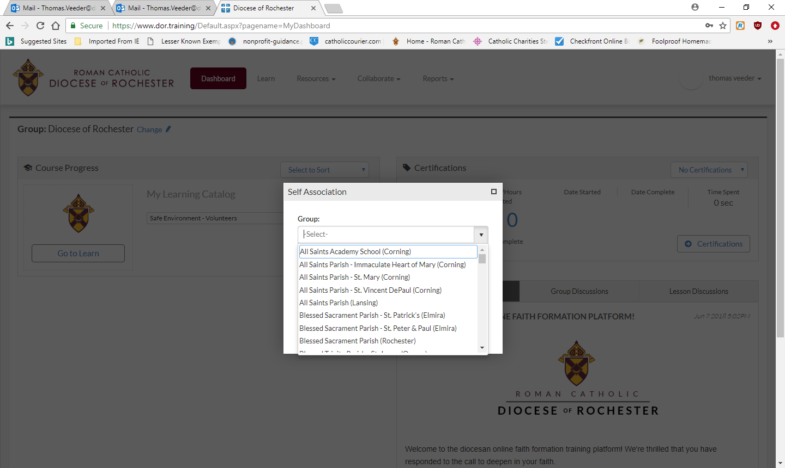

- Click on “Go to Learn” to begin your training.
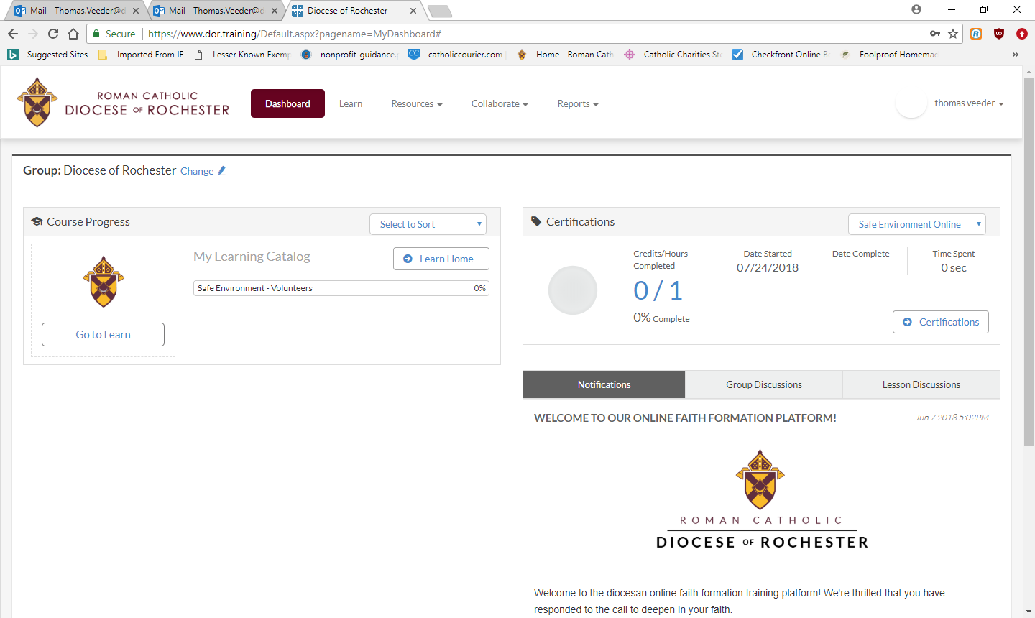
Notes:
You must complete all 5 parts of the safe environment training for volunteers. Please do these in order. Each of the first four courses ends with quiz questions. To go to the next course, click the button that says “return to activities” in the top left-handed corner.
You may stop and log out between courses.
When you have completed all 5 parts, please print your certificate and give a copy to your parish/school Creating a Safe Environment (CASE) Coordinator. At OLOL that is Patty Larzelere, or through Erika Holland at St. Michael’s School.
You will also need to read, sign and return the Volunteer Code of Conduct as well as the 2017 Background Authorization, with proof of identity. If your proof of identity is an enhanced NYS Driver’s License or a US Passport, you do not need to write in your SSN. Once the certificate, code of conduct, copy of proof of identity and authorization are received, it will take about 7-10 days for you to be informed that you are cleared for volunteering. You will get an email from Patty informing of this.
If you will also be driving for SMS or OLOL, you will need to complete and return the Driver form, which only checks your driving record.
Thank you for ministering with us!

