Registration for Confirmation in

Our Lady of the Lakes Catholic Community
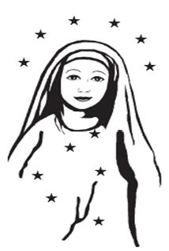
Worshipping at Mass and sharing the Good News of Christ’s life, death and resurrection is everyone’s mission. Developing our relationship with God and His people is a lifetime assignment. Youth worshipping, participating in Parish Life, and learning about God and their faith, and claiming it for themselves is the basis for the 2 year Confirmation preparation process. Students who are entering 8th grade or higher are eligible. Complete and return this form to 210 Keuka St., Penn Yan, NY 14527. Instruction for both years is done intensively, over the summer, with monthly assignments and face-to-face follow-ups throughout the school year. Call for more details.
Today’s date: ____________ Student’s full Name: _________________________________________
School & Grade: _____________________ Any Special Needs? ____________________________
Place & DOB: ______________________________
Circle Sacraments received: Baptism Reconciliation Holy Eucharist
If not baptized in OLOL, please provide a copy of the child’s Baptismal Certificate.

Currently receiving religious education through (please circle one):
OLOL Family Faith Formation Home schooled Catholic school: __________________

Worship site & Mass time family usually attends: ___________________________________________
Parents’/guardians’ Legal Names: ________________________________________________________
Family Address: _______________________________________________________________________
Best way to contact us is by ______________________________________________________________
Mom’s Email: ________________________________ Phone: ________________________________
Dad’s Email: ________________________________ Phone: ________________________________
You will receive a schedule of specifics. The fee of $60 is due now. Please submit with this.
You agree that you and your child will make attendance a priority, missing any sessions only for reasons of illness and calamity. Missed lessons need to be made up. They will involve extra time and effort. We experience Jesus’ love for us in the Sacraments. Therefore, thoughtful, joyful, active preparation is a must.
Parent’s Signature: ________________________________ Student’s Signature: ______________________________

