Our Lady of the Lakes

Registration for 1st Holy Communion*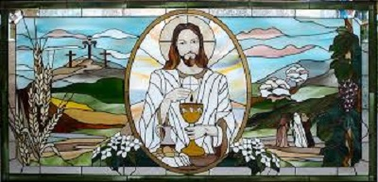
*Diocesan guidelines specify that anyone preparing for sacraments needs to have completed a full year of Religious Education (either through a Catholic school or parish religious ed. program). Candidates also must have been prepared and celebrated the Sacrament of Penance & Reconciliation.
Print legibly & return to the Parish Center by 9/29/2019
Candidate’s Full Name: ________________________________ School & Grade: ________________
Place & DOB: ___________________________________________
Name of church & place where baptized: _________________________________________________
(If not in OLOL, please provide a copy of the child’s Baptismal Certificate.)

Currently receiving religious education through (please circle one):
OLOL Family Faith Formation St. Michael’s/other Catholic School Home Schooled
Received Reconciliation/Confession/Penance at: ________________________________ Year: _______

Worship site & Mass time family usually attends: ___________________________________________
Parents’/guardians’ Legal Names: ________________________________________________________
Best way to contact us is: ____________________________________________________________________________
Mom’s Phone: __________________ Email: ________________________ Maiden Name: ___________________
Dad’s Phone: ________________________________ Email: _________________________________
Family Address: _______________________________________________________________________
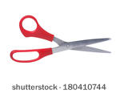 Dates & times for Eucharist preparation are as follows:
Parents only: Sunday, January 26 @ 1 PM @ the OLOL Parish Center, 210 Keuka St., Penn Yan 315-536-7459
Parents & candidates: Sundays: 2/23, 3/15 & 4/19 from 1-3 PM @ St. Mike’s Parish Center, Penn Yan
Celebration: TBD (at any of the regularly scheduled Masses during the Easter season, during the Mass at which the family usually worships.) The Sacrament of Reconciliation should be celebrated prior to the celebration of 1st Holy Communion.
Thank you. We, the OLOL staff, look forward to working with you and your child/ren. Peace be with you.

