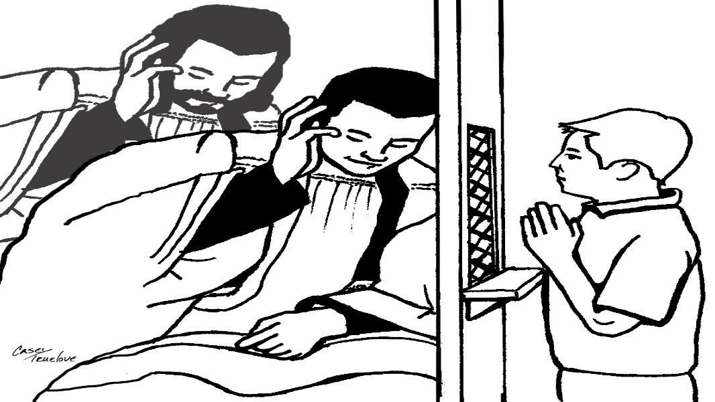

Registration for RECONCILIATION*
*Diocesan guidelines specify that anyone preparing for sacraments needs to have completed a full year of Religious Education (either through a Catholic school or parish religious ed. program).
Print legibly & return to the Parish Center** by 9/15/2019
Candidate’s Full Name: __________________________________ School & Grade: ________________
Place & DOB: ____________________________________________________
Name of church & place where baptized: __________________________________________
(If not in OLOL, please provide a copy of the child’s Baptismal Certificate.)

Worship site family usually attends & Mass time: ___________________________________________
Currently receiving religious education through (please circle one):
OLOL Family Faith Formation St. Michael’s/other Catholic School Home Schooled
Parents’/guardians’ Legal Names: ________________________________________________________
Best way to contact you is: ______________________________________________________________
Mom’s Phone: __________________ Email: ________________________ Maiden Name: ___________________
Dad’s Phone: ________________________________ Email: _________________________________
Family Address: _______________________________________________________________________

Dates, times & locations for Reconciliation preparation are as follows:
Parent only meeting is TBD 1 PM in the Parish Center** living room
Parents & candidates: Sundays, TBD from 2-4 PM @ St. Mike’s Parish Center
Thank you. We, the OLOL staff, look forward to working with you and your child/ren.
Peace be with you. ** 210 Keuka St., Penn Yan, NY 14527 315-536-7459

