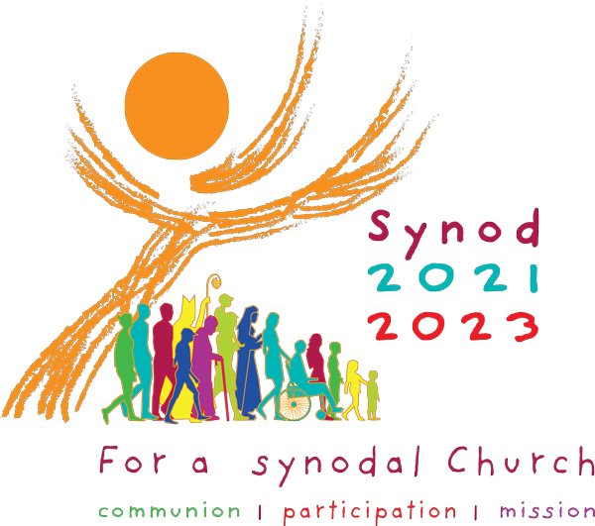
Here is an overview of the Synod and its process. Synod is one of those words from our Catholic vocabulary that means “walking/dreaming together.” POPE FRANCIS wants to hear from all people. This world-wide synod’s central question is,” What steps does the Holy Spirit invite us to take in order to grow in our “journeying together”? Its official title is: “For a Synodal Church: Communion, Participation and Mission.” This question can only be answered when the Holy Spirit, all people and the Magisterium (another word in our Catholic lexicon, which means the teaching authority of the Church) are discerning and conversing together.

This synod calls us to “spend time with the future.” What inspires us? What are our dreams for the Church? As the Bride of Christ, how will we make hopes flourish? Stimulate trust? Bind up wounds? Weave new and deeper relationships? Learn from one another? Build bridges? Enlighten minds? Warm hearts? Restore our strength for our common mission? (Taken from the Preparatory Document, paragraph 32.)

All are called to participate: Church goers, non-church goers, the disenfranchised, the excluded and forgotten. Being synodal requires time for sharing; humility in listening, which must correspond to courage in speaking; dialogue leading to newness; openness to conversion and change. It will be necessary to leave behind prejudices and stereotypes, overcome the thinking that clerics (priests and other religious) are above society’s rules and morally superior, cure the virus of self-sufficiency, overcome ideologies, and give us rise to hope. During the conversation, no one’s ideas or opinions are more important than another’s.

The Synod has goals. "By walking together, and together reflecting on the journey made, the Church will be able to
- Learn from what it will experience
- Understand which processes can help it to live communion,
- Achieve greater participation for all
- Build a foundation where committing to mission and fulfilling mission is encouraged and possible.
The synod has a timeline. Beginning on October 17, 2021, we are to pray and reflect on the information offered in the Preparatory Document, available at www.dor.org/synod. This is phase one. During phase two, November 15, 2021 – February 28, 2022, conversations about “being Church,” and “journeying together,” will take place among various entities (parish ministries, charitable organizations, special focus groups, etc.) Input from these gatherings will be submitted to our Diocese by February 28, 2022. The Diocese will synthesize all comments into a 10-page report to be sent to the USCCB by April 1, 2022. In the third phase the USCCB (as well as all the continental Bishop’s councils) will compile all the input and take it to Rome for the October 2023 Synod of Bishops.

The synod’s official prayer is:

“We stand before You, Holy Spirit, as we gather together in Your name. With You alone to guide us, make Yourself at home in our hearts; Teach us the way we must go and how we are to pursue it. We are weak and sinful; do not let us promote disorder. Do not let ignorance lead us down the wrong path nor partiality influence our actions. Let us find in You our unity so that we may journey together to eternal life and not stray from the way of truth and what is right. All this we ask of You, who are at work in every place and time, in the communion of the Father and the Son, forever and ever. Amen.” -- St. Isidore of Seville (560-636)

More information will come to us in various ways. The best way to keep updated is by visiting the Diocese’s synod webpage: www.dor.org/synod. Additionally, check the parish bulletin & website, The Catholic Courier, and parish and diocesan social media channels. Listen for announcements at Mass.

