“Every twenty-five years, the Catholic Church celebrates a sacred Jubilee to encourage special prayers and sacred pilgrimages. From Christmas Eve in 2024 to the Epiphany on January 6, 2026, Pope Francis invites us to be “Pilgrims of Hope.” Catholics are encouraged to embark on a holy journey, known as a pilgrimage, to Rome or other sacred sites closer to home. The holy doors of the four major basilicas are normally cemented shut, but during Jubilee Years they are opened! Pilgrims will enter these sacred buildings through the holy doors as a symbol of salvation through Jesus Christ, who once called himself “the gate” through which we are saved (Jn 10:9).

“But you don’t have to go to Rome to celebrate the Jubilee! Pilgrims can gain a special grace called an indulgence either for themselves or the souls in purgatory by visiting the four major basilicas, but also through visits to other sacred sites designated by local bishops. Additionally, we can obtain an indulgence by practicing works of mercy, such as giving to the poor or visiting the sick, or by performing acts of penance like fasting from food, devices, or entertaining media. This 2025 Jubilee is a special opportunity to experience God’s love as “pilgrims of hope.” Jared Dees

## **Understanding Plenary Indulgences**

To seek an indulgence is to seek the experience of God’s infinite mercy. As Pope Francis reminds us in his papal bull establishing the Jubilee: “Indeed, the *indulgence* is a way of discovering the unlimited nature of God’s mercy. Not by chance, for the ancients, the terms ‘mercy’ and ‘indulgence’ were interchangeable, as expressions of the fullness of God’s forgiveness, which knows no bounds.” (*Spes Non Confundit*, 23).

During the Jubilee Year, all faithful Catholics “who, during the Holy Year, purified through the sacrament of reconciliation and refreshed by Holy Communion, pray for the intentions of the Supreme Pontiff, (**the ordinary dispensation requirements**) will be able to obtain from the treasury of the Church a plenary indulgence” can receive an indulgence in the following ways:

1. Pilgrimage to Rome, the Holy Land, or local cathedrals and sacred sites designated by the local bishop
2. Pious visits to sacred places designated as Jubilee sites
3. Works of mercy*
4. Acts of penance

[What are Catholic Indulgences?](https://www.youtube.com/watch?v=3R9Ms8utzO4&t=10s) Indulgences remove the need for punishment of/attachment to our sins.

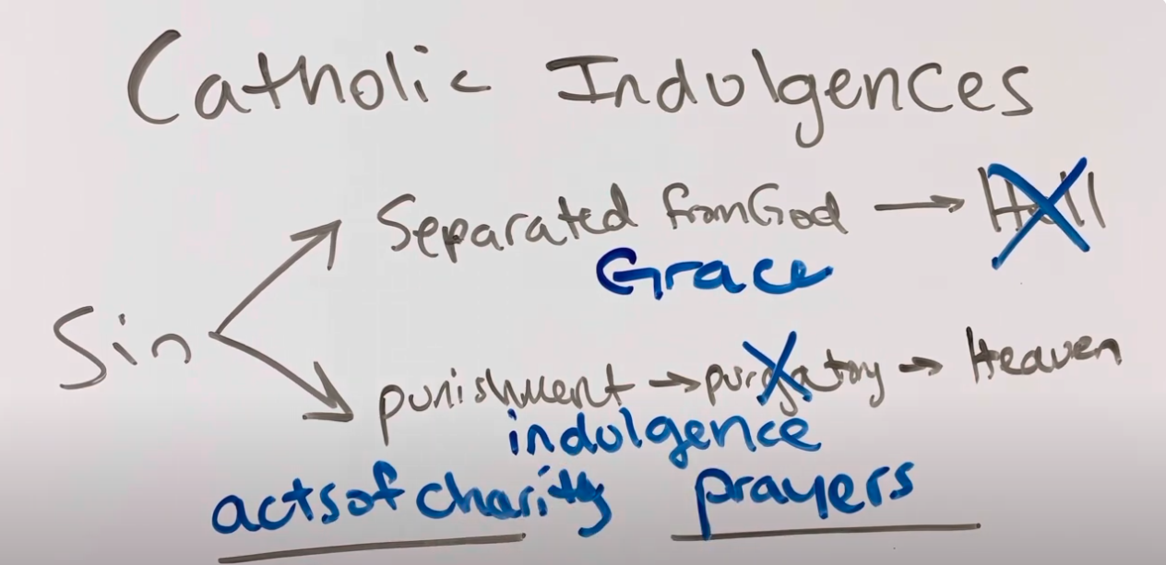By Jesus’ passion/ death and resurrection, we are Heaven bound; God’s grace puts us on the right path. Frequent sacramental reconciliation allows more grace into our lives.

Indulgences shorten the time souls spend in Purgatory, a place where we are refined for Heaven.

Ways to receive an indulgence, after meeting **the ordinary dispensation requirements**:

* Perform acts of charity (love) -- Could be monetary donations, but also serving the poor/ those in need.
* Pray

Here are some suggestions from the Jubilee decree on indulgences:

“In particular the penitential nature of Friday can be rediscovered through abstaining, in a spirit of penance, at least for one day of the week from futile distractions (real but also virtual distractions, for example, the use of the media and/or social networks), from superfluous consumption (for example by fasting or practising abstinence according to the general norms of the Church and the indications of the Bishops), as well as by donating a proportionate sum of money to the poor; by supporting works of a religious or social nature, especially in support of the defence and protection of life in all its phases, but also by supporting the quality of life of abandoned children, young people in difficulty, the needy or lonely elderly people, or migrants from various countries “who leave their homelands behind in search of a better life for themselves and for their families” (*Spes non confundit,* 13); it can also be obtained by dedicating a reasonable portion of one’s free time to voluntary activities that are of service to the community or to other similar forms of personal commitment.”

In summary, especially on Fridays, abstain from

* mobile devices
* distractions such as social media
* meat
* snacks

Perform Acts of Charity, by

* donating money to the poor
* supporting work of non-profits and charities (especially those dedicated to children, elderly, and migrants)
* volunteering time in community service
* By performing any of the Works of Mercy (Corporal or Spiritual)

Everyone can participate in a Jubilee Year by

* Going on a pilgrimage
* Performing works of charity and mercy: Corporal of Spiritual
* Performing acts of penance

From Jared Dees

[Jubilee Year Lesson Plan, Activities, & Worksheet | The Religion Teacher | Catholic Religious Education](https://www.thereligionteacher.com/jubileeyear-lessonplan-activities/?utm_source=The+Religion+Teacher+Newsletter+List&utm_campaign=a523c537d3-TRT%3A+Weekly+Newsletter+1-12-25&utm_medium=email&utm_term=0_a52a2eb0e6-a523c537d3-326869361&mc_cid=a523c537d3&mc_eid=2f8adcdc16)