Understanding the Theme: “Pilgrims of Hope”

“During the Holy Year, we are called to be tangible signs of hope for those of our brothers and sisters who experience hardships of any kind.”  
—Pope Francis, Spes Non Confundit, 10

The logo for the Jubilee Year features four stylized people (symbolizing the people coming from the four corners of the globe) reaching for the cross, which takes the shape of the symbol of hope: the anchor.

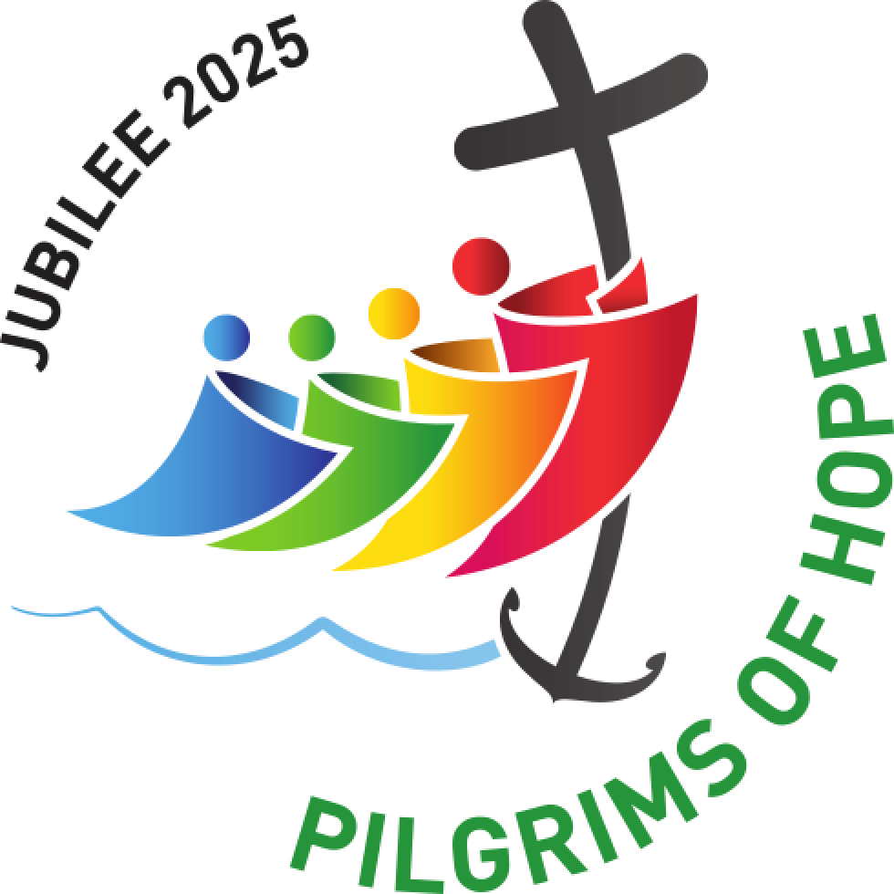

The classic symbol of Hope is a ship’s anchor. Why? Because the anchor keeps the ship from going adrift. The anchor for Christians is faith in Jesus. When our lives are anchored in Him, we cannot go very far adrift. God’s grace and mercy is always calling us closer, like when an anchored ship needs to “pull anchor” to go to another place.

From Jared Dees, <https://www.thereligionteacher.com/jubileeyear-lessonplan-activities/?utm_source=The+Religion+Teacher+Newsletter+List&utm_campaign=a523c537d3-TRT%3A+Weekly+Newsletter+1-12-25&utm_medium=email&utm_term=0_a52a2eb0e6-a523c537d3-326869361&mc_cid=a523c537d3&mc_eid=2f8adcdc16>